

**American International University-Bangladesh**

**Course Name: Introduction to Database[F]**

**Course Code: CSC 2107**

**Project Final Report**

**HOSPITAL MANAGEMENT SYSTEM**

**Submitted To: NASHIA AHMED NABILA**

**Course Instructor**

**Submitted By :**

|  |  |
| --- | --- |
| **NAME** | **ID** |
| **JUBAYER,MD.AL** | **14-27544-3** |

**Table of contents:**

|  |  |  |
| --- | --- | --- |
|  | **PART A** |  |
| **No** | **Content** | **Page No** |
| **01** | Cover page | **01** |
| **02** | Table of contents | **02** |
| **03** | Business and system summary | **03** |
| **04** | Give an overview of the business environment and project objectives | **03-04** |
| **05** | Give a brief technical summarization of your developed database | **04** |
| **06** | Justify how your developed database meets the project objectives, and how it will support the business. | **05** |
| **07** | An ERD diagram in the original | **06** |
| **08** | Normalize the database 3th normal form | **07-09** |
| **09** | A database relationship diagram, clearly showing every table, attributes, and date type. | **10** |
| **10** | Description of each table in a screen shot. | **11-14** |
| **11** | Enter 5 rows in each table and give screenshot of every table with data. | **15-16** |
|  |  |  |
|  |  |  |
|  | **PART B** |  |
| **12** | Learning Experience | **17** |
| **13** | Summary | **17** |

**Business and System Summary :**

Hospital Management System (HMS) has been designed to streamline the business practices of hospitals and clinics. Through its electronic patient information system, HMS ensures optimum use of the medical records of patients. Being patient-centric, the system makes it possible for all disparate files on a patient to be housed in a centrally located master file, ensuring retrieval and management of files effortless. Plus, easy integration ensures a faster start up.

HMS has been so designed as to make its usage intuitive, which makes adoption of HMS by the hospital personnel quick and easy. Its high level of scalability ensures quick upgrades when change in the hospital's business practices so demands. What is more, with information collection, collation and retrieval all digitized, patient care regains top of mind status with physicians and hospital personnel.

To round off, our Hospital Management System provides the benefits of streamlined operations, enhanced administration and control, superior patient care, strict cost control and improved profitability.

It has been observed that every organization falls into a growth cycle once it is truly organized. The major mode of organization in the healthcare system is an established IT backbone.

Hospital Software is such software that enables the administration to run the organization smoothly.

It empowers the management to visualize the entire business happening of the organization sitting in front of a PC.

Hospital Software helps you to understand the vital elements of your business and gives you most vital information regarding your future trends and necessary corrective action. Therefore this solution takes non-parallel care of each and every information need of a modern hospital unlike just a package made by computer professionals for whom it is not possible to understand the intricacies of the health care management, thus, it is a Hospital Software touch.

**Business Environment :**

The project ‘Hospital Management System’ is based on the database. As there are many areas where we keep the records in database for which we are using ORACLE 11g Express Edition software which is one of the best and the easiest software to keep our information.

**Project Objective :**

Hospital are the essential part of our lives, providing best medical facilities to people suffering from various ailments, which may be due to change in climatic conditions, increased work-load, emotional trauma stress etc. It is necessary for the hospitals to keep track of its day-to-day activities & records of its patients, doctors, nurses, ward boys and other staff personals that keep the hospital running smoothly & successfully.

But keeping track of all the activities and their records on paper is very cumbersome and error prone. It is also very inefficient and a time-consuming process Observing the continuous increase in population and number of people visiting the hospital. Recording and maintaining all these records is highly unreliable, inefficient and error-prone. It is also not economically & technically feasible to maintain these records on paper.

Thus keeping the working of the manual system as the basis of our project. We have developed an automated version of the manual system, named as “HOSPITAL MANAGEMENT SYSTEM”.

**Technical Summary of the Database :**

Hospital management system is a computerized system designed and programmed to deal with day to day operations taking place. The program can look after inpatients, outpatients, records, database treatments, status illness, billings in the pharmacy and labs. It also maintains hospital information such as ward id, doctors in charge and department administering. The purpose of the project is to computerize the Front Office Management of Hospital to develop software which is user friendly, simple, fast, and cost – effective. It deals with the collection of patient’s information, diagnosis details, etc. Traditionally, it was done manually. The project outlines all the process followed to come up with the software that is from analysis to testing the system

**Justification of the Developed Database :**

The working in the organization will be well planned and organized. The data will be stored properly in data stores, which will help in retrieval of information as well as its storage.

The level of accuracy in the proposed system will be higher. All operation would be done correctly and it ensures that whatever information is coming from the center is accurate.

In the proposed system utmost care would be that no information is repeated anywhere, in storage or otherwise. This would assure economic use of storage space and consistency in the data stored.

The main objective of proposed system is to provide for a quick and efficient retrieval of information. Any type of information would be available whenever the user requires.

The system should be easy to operate and should be such that it can be developed within a short period of time and fit in the limited budget of the user.

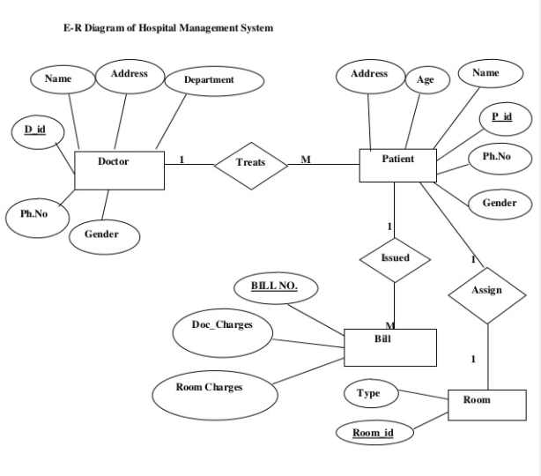

# Normalization (Up to 3rd Normal Form)

**1st Normalize Form :**

Doctor-patient:

|  |  |  |  |  |  |  |  |  |  |  |
| --- | --- | --- | --- | --- | --- | --- | --- | --- | --- | --- |
| d_id | d_name | d_dob | d_dept | d_gender | d_contact_no. | P_id | P_name | P_dob | P_gender | P_contact_no. |

**Functional dependency :**

d_id,p_id(d_name,d_add ,d_dob,d_dept,d_gender,d_contact no. ,p_name,p_ add, p_dob,p_gender,p_contact no)

**partial dependency :**

d_id(d_name,d_add ,d_dob,d_dept,d_gender,d_contact no)

p_id(p_name,p_add,p_dob,p_gender,p_contact no)

**2st Normalize Form :**

**Doctor:**

|  |  |  |  |  |  |  |
| --- | --- | --- | --- | --- | --- | --- |
| d_id | d_name | d_add | d_dob | d_contact_no. | d_gender | P_id |

**Patient:**

|  |  |  |  |  |  |
| --- | --- | --- | --- | --- | --- |
| p_id | p_name | d_add | p_contact_no | p_dob | p_gender |

**3st Normalilze Form:**

**Doctor:**

|  |  |  |  |  |  |  |
| --- | --- | --- | --- | --- | --- | --- |
| d_id | d_name | d_add | d_dob | d_contact_no. | d_gender | P_id |

**Patient:**

|  |  |  |  |  |  |
| --- | --- | --- | --- | --- | --- |
| p_id | p_name | p_add | p_contact_no | p_dob | p_gender |

**1st Normal Form:**

**Patient-Room:**

|  |  |  |  |  |  |  |  |
| --- | --- | --- | --- | --- | --- | --- | --- |
| p_id | p_name | p_add | p_dob | p_contact_no. | p_gender | r_type | r_id |

**Functional dependency:**

p_id,r_id(p_name, p_dob, p_contact no. , p_gender, r_type)

**Partial dependency:**

p_id(p_name,p_dob,p_contact no.,p_gender)

r_id:(r_type)

**2nd Normal Form:**

**Patient:**

|  |  |  |  |  |  |  |
| --- | --- | --- | --- | --- | --- | --- |
| p_id | p_name | p_add | p_contact_no | p_dob | p_gender | r_id |

Room:

|  |  |
| --- | --- |
| r_id | r_type |

**3rd Normal Form:**

**Patient:**

|  |  |  |  |  |  |  |
| --- | --- | --- | --- | --- | --- | --- |
| p_id | p_name | P_add | p_contact_no | p_dob | p_gender | r_id |

**Room:**

|  |  |
| --- | --- |
| r_id | r_type |

**1st Normal Form:**

Patient-Bill:

|  |  |  |  |  |  |  |  |  |
| --- | --- | --- | --- | --- | --- | --- | --- | --- |
| p_id | p_name | p_add | P_dob | p_contact_no | p_gender | Bill_no | Doc_charge | Room_charge |

Functional dependency:

P_id,Bill_no:(p_name, p_dob, p_contact no. , p_gender, doc_charge,room_charge)

Partial dependency:

p_id(p_name,p_dob,p_contact no.,p_gender)

Bill_no:(doc_charge,room_charge)

**2nd Normal Form:**

Patient:

|  |  |  |  |  |  |  |
| --- | --- | --- | --- | --- | --- | --- |
| p_id | p_name | p_add | p_contact_no | p_dob | p_gender | Bill_no |

Bill_no:

|  |  |  |
| --- | --- | --- |
| Bill_no | Doc_charge | Room_charge |

**3rd Normal Form:**

**Patient:**

|  |  |  |  |  |  |  |
| --- | --- | --- | --- | --- | --- | --- |
| p_id | p_name | p_add | p_contact_no | p_dob | p_gender | Bill_no |

**Bill_no:**

|  |  |  |
| --- | --- | --- |
| Bill_no | Doc_charge | Room_charge |

**Database relationship diagram :**

|  |
| --- |
| **Bill** |
| bill_no (number)  doc_charge (number)  room_charge(number) |

|  |
| --- |
| **Room** |
| r_id (number)  r_type (varchar2) |

|  |
| --- |
| **Patient** |
| p_id (number)  p_name (varchar2)  p_dob (varchar2)  p_contact_no (number)  p_gender (varchar2)  r_id  bill_no |

|  |
| --- |
| **Doctor** |
| d_id (number)  d_name (varchar2)  d_dob (varchar2)  d_contact_no(number)  d_gender (varchar2)  p_id |

**Table description (Bill):**

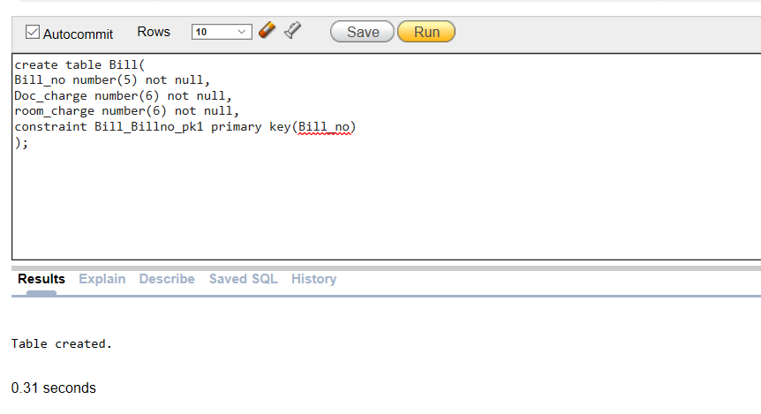

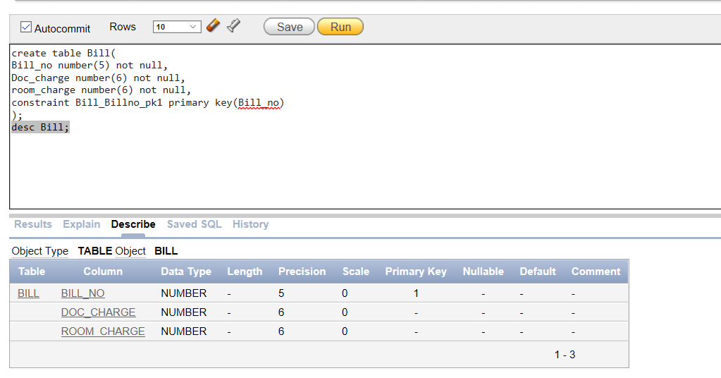

**Table description (Room):**

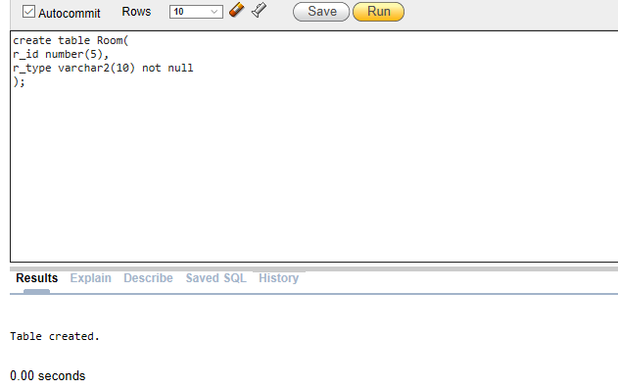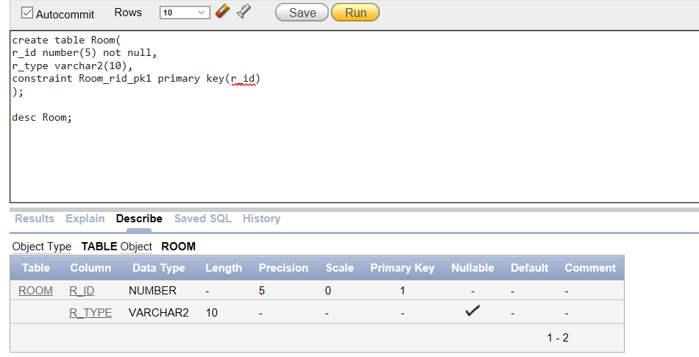

**Table description (Patient):**

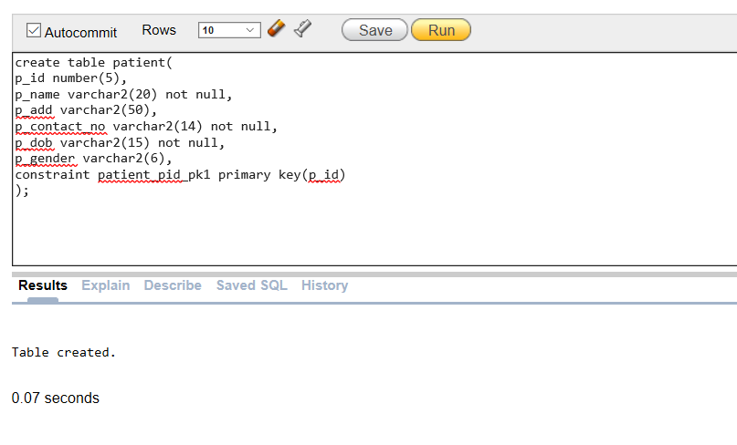

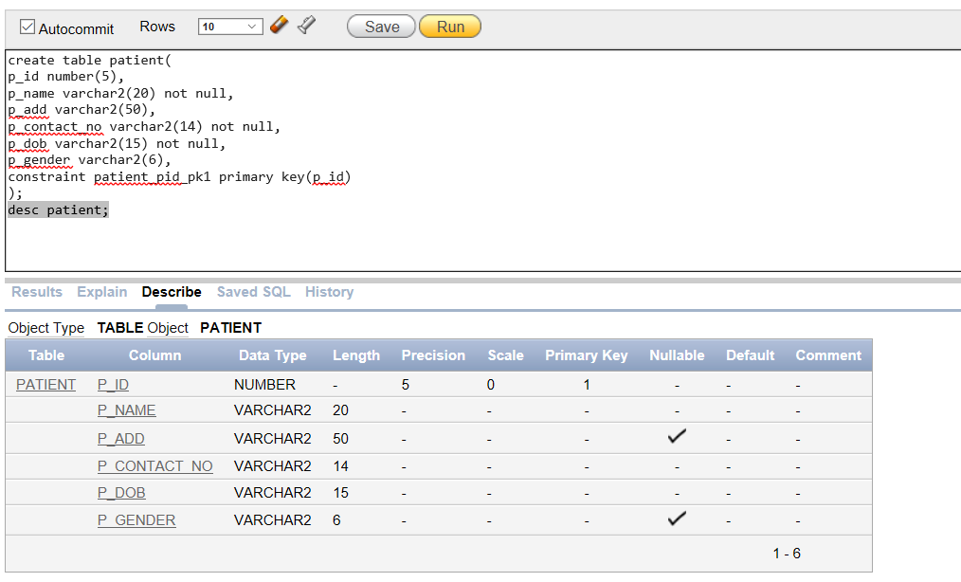

**Table description (Doctor):**

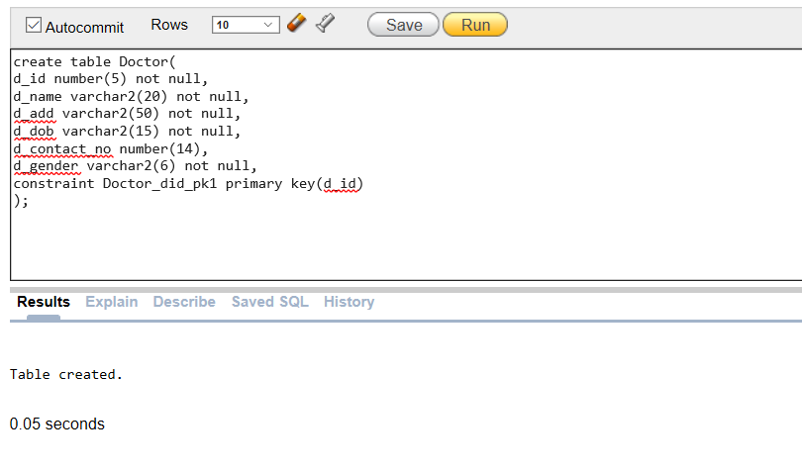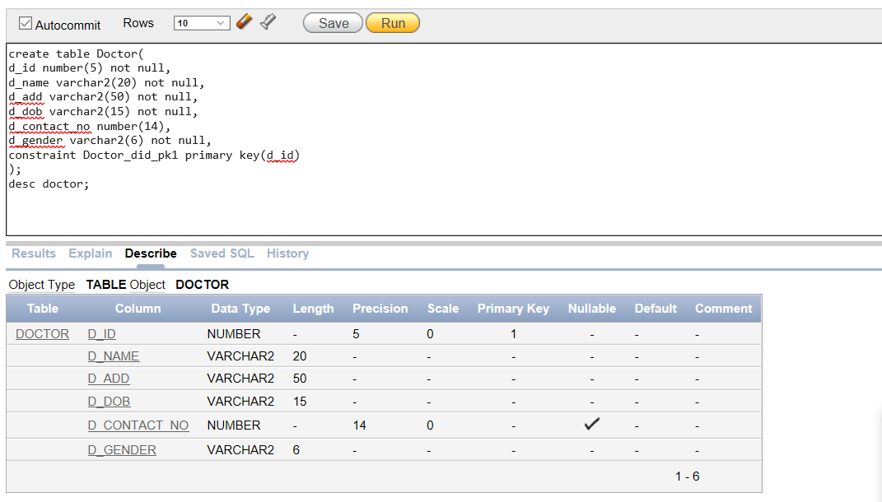

**Insertion rows(Bill):**

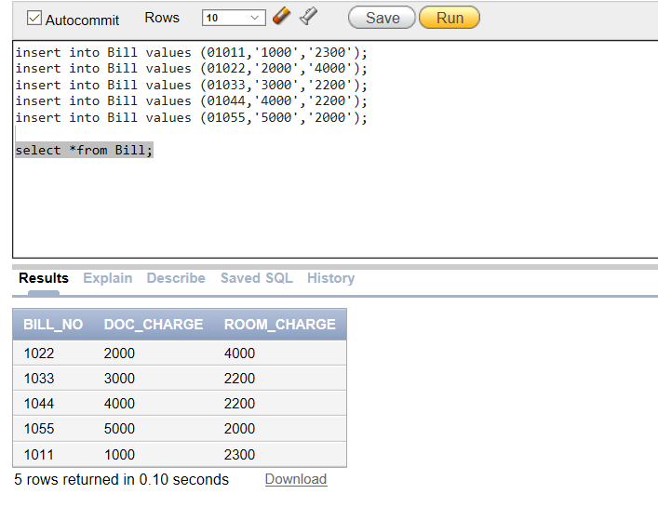

**Insertion rows(Room):**

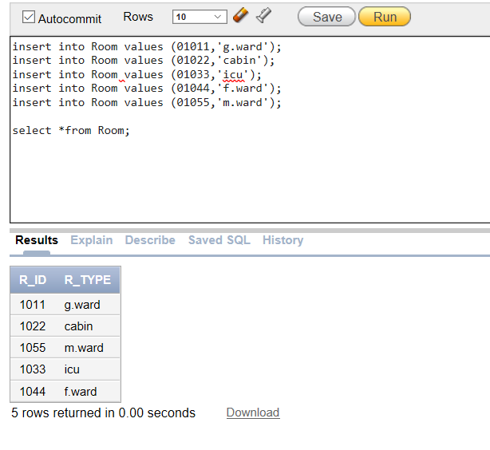

**Insertion rows(Patient):**

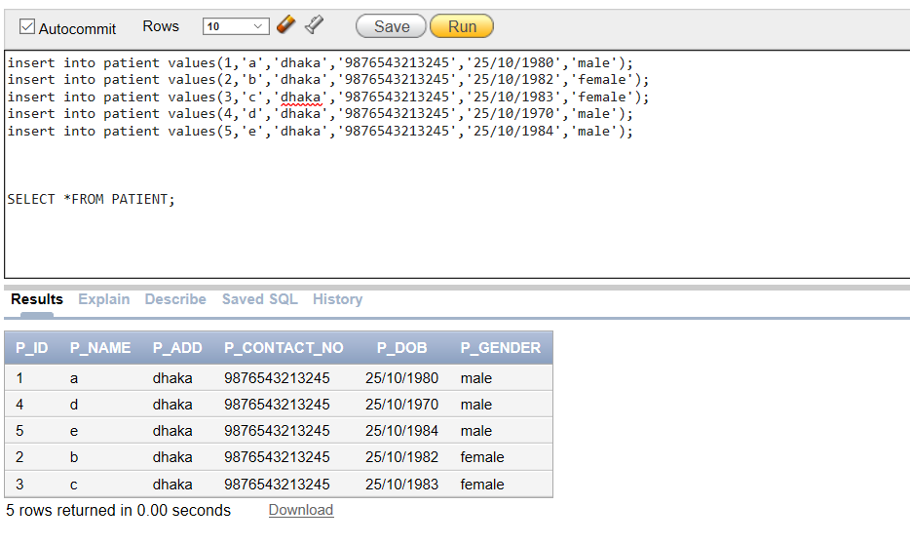

**Insertion rows(Doctor):**

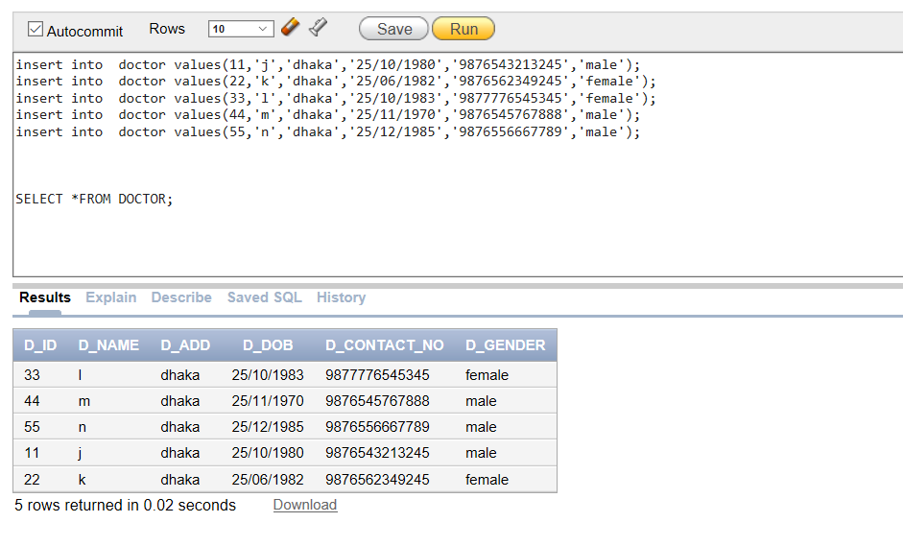

**PART B**

**Learning Experience:**

This project has been a rewarding experience in more than one way. The entire project work has enlightened to me in following areas :

1. I have gained an insight into the working of the hospital. This represents a typical real world situation.

2. I have learned how to work and create a database project by using oracle software.

3. During working time, I could face many difficulties. And then I have learned how to overcome those type of difficulties.

**Summary:**

Despite of my best effort, there might be some error in my developed database. I have learned from my mistakes and applying this knowledge, I hope I will gain from this project to create more professional level database in tfuture.